**Department of Mechanical Engineering**

**University of California, Berkeley**



**ME 102B: Mechatronics Design**

**Spring 2021**

**Professor Kazerooni**

**Implementation of UAVs to Combat Climate Change**

Leon Guo, Yelena Sukhanov, Hams Laeeq, Andy Reddy, Jeffery Tsang

1. **Description**

Climate change is one of the pressing issues of our day. Studies have shown that the recent uptick in the intensity and frequency of wildfires is directly related to ambient temperature, soil moisture, and regional flora, all factors which are tied to a changing climate. Droughts, build-up of fuel, and more severe weather patterns have created a longer fire season and increased the probability of more intense and recurring blazes. Not only do wildfires present an immediate danger to the regional ecosystem and the people residing nearby, they also represent a serious health risk and financial cost to our society. Wildfires have resulted in billions of dollars of damages in the past two decades in the United States alone, and pose a threat to those with respiratory problems within a radius hundreds of miles of the epicenter of the fire. Thus, it is highly imperative to develop and execute a fire detection and extinguishing system, especially for high-risk areas that have been more acutely affected by droughts.

In order to solve the aforementioned problem, a UAV will be used to detect wildfires. A camera will be attached to a drone, which will autonomously and routinely survey a geographical area. Image processing will be used in order to detect and locate the wildfire. Communication will be conducted via satellite between the drone interface and external equipment used to interpret the data. If a wildfire is detected, the drone will drop a chemical agent to reduce the spread of the fire. It will also determine the perimeter of the fire that must be contained, and potential hikers or rural residents who must be notified and potentially rescued.

For the purposes of this initial proof-of-concept project, we will have a drone locate a candle in a field, report the location, and then drop a load in a precise location which in the scaled-up version of this project will be a chemical fire retardant.

1. **Design**

The system will be constructed around a Tello EDU drone. This model features easy customization, precision flight control, and is compatible with AI functions.

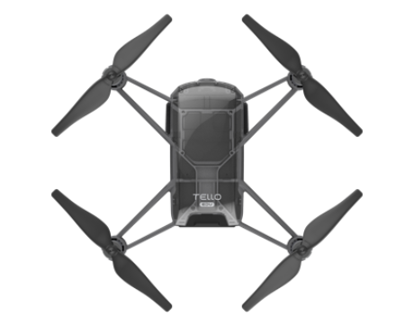

***Figure 1:*** Tello EDU

A mechanical arm will be attached to the underside of the UAV which will automatically deploy a payload of chemical fire retardant upon detection of a wildfire. In our small-scale prototype it will deploy an object to simulate functionality.

In order to protect the system from the high temperatures which may exist near wildfires, a coating of heat reflective paint will be applied to the exterior of the UAV. To protect it from ambient humidity and the elements, a waterproofing layer of paint will be applied as well.

Communication will be executed through the use of satellite, which is widely available even in rural areas such as where the UAV will be employed.

The drone will recharge via a charging pad which it will periodically return to in between fire detection flights. Charging will be conducted via solar cells, with the option for an additional lithium ion battery as a backup power source during flights.

1. **Electromechanical Details**
2. **Software Details**
3. **Circuit Diagram**
4. **Finite State Machine**
5. **Fabrication**

Our prototype will be constructed in a home laboratory, however large scale manufacturing will be required for the final design.

1. **Specifications**

| Longevity | $5 years$ |
| --- | --- |
| Maintenance | $1 year$ |
| Flight Time | $13 minutes$ |
| Charge Time | $7 minutes$ |
| Velocity | $10 \frac{m}{s}$ |
| Maximum Range | $10 km$ |
| Maximum Load | $10 kg$ |
| Maximum Temperature | $750 ∘C$ |

1. **Discussion and Applications**

*V.1 Choice of Design*

Each design choice has been carefully considered in order to balance the longevity of the design with the overall cost of manufacturing and maintenance. Although there is an initial production cost the annual maintenance is relatively low, the unit will be in use for many years.

*V.2 Methods of Use*

In order to optimize wildfire detection, this system must be implemented on a large scale.

To begin with, high risk regions affected by extreme droughts will be selected. One unit (consisting of a single UAV and launch pad charging station) per $10 {km}^{2}$ will be installed. These UAVs will be automatically deployed when fire danger is moderate, high, or extreme, or as recommended by park rangers and wilderness experts.

*V.3 Other Applications*

Another potential application of this concept is the detection of drowning swimmers via UAVs. Similar to the previous analysis, a drone will autonomously survey bodies of water frequented by surfers and swimmers, and image processing will be used to detect the drowning victim. Upon detection, the drone will drop a life jacket to the precise location of the swimmer, report the location, and request additional help to be sent immediately.

1. **Conclusion**

Using the knowledge we learned about mechatronics design, we produced a novel device which senses wildfires, provides an immediate solution, and relays indispensable information to firefighters. We believe this is the best immediate method for combating wildfires, given its simplicity and reliability in rural locations and potentially harsh climates. Furthermore it is our belief that our device will greatly benefit the general public, as well as the overall health of the environment.

**Acknowledgements**

We would like to acknowledge and thank Professor Kazerooni for the invaluable guidance of the information provided to us this semester. We understand this semester was quite unlike any other, and we want to show our appreciation for his willingness to still introduce us to the field of mechatronic design.

**References**

[1] Tello official WEBSITE-SHENZHEN Ryze Technology co.,ltd. (n.d.). Retrieved April 24, 2021, from <https://www.ryzerobotics.com/tello-edu?from=store-product-page>